

SAVEETHA SCHOOL OF ENGINEERING

SAVEETHA INSTITUTE OF MEDICAL AND
TECHNICAL SCIENCES

DEPARTMENT OF COMPUTER SCIENCE AND ENGINEERING

LIST OF EXPERIMENTS

COURSE CODE : CSA4001
COURSE NAME : MANAGEMENT INFORMATION SYSTEM

9 A college has more than thousand security persons, who are instructed to give duties at different places within the campus. Additionally, they also maintain a routine, which contains all information, such as Date, Duty Start Time, Duty End Time, and Place. Most importantly, all the places are covered by at least one security person. If a security person takes leave, manual entry is done against that person. Finally, at the end of a month, the security persons get paid for their duties, while considering the number of leaves as well. You can see that the manual calculation/operation is a heavy task for the security manager. Therefore, the objective is to build an Online security management system using class diagram through which entire security system within the campus can be controlled in an efficient manner

AIM:
To design an Online Security Management System for a college, using a class diagram to efficiently control the security system, including duty scheduling, leave management, and payment calculation.

PROCEDURE:
• Identify Key Classes:
The key classes include SecurityPerson, DutySchedule, LeaveRequest, Payment, and SecurityManager.
• Define Relationships:
- A SecurityPerson has attributes such as name, ID, and assigned duties.
- A DutySchedule contains the Date, Duty Start Time, Duty End Time, and Place.
- A LeaveRequest records the dates and reasons for leave.
- A Payment calculates the payment based on the total duty hours minus the leave days.
- SecurityManager manages the system, assigns duties, processes leaves, and calculates payments.
• Implement Class Methods:
Methods will include adding and modifying duty schedules, submitting leave requests, and calculating the payment at the end of the month.
• Generate Class Diagram:
Visualize the relationships and methods in the class diagram.

OBSERVATION:

USECASE DIAGRAM:
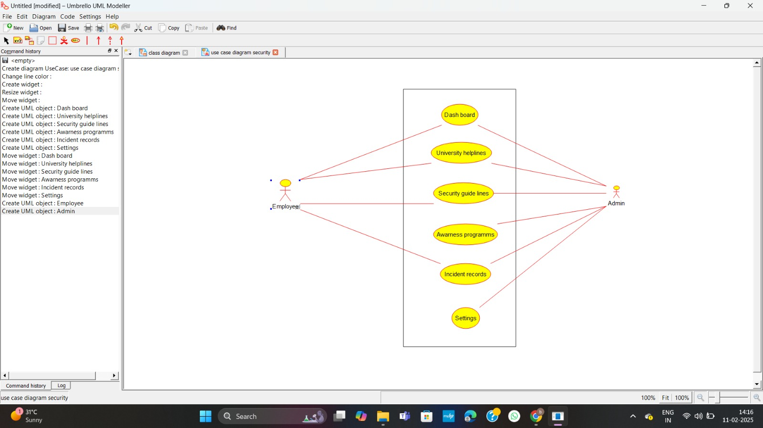

CLASS DIAGRAM:
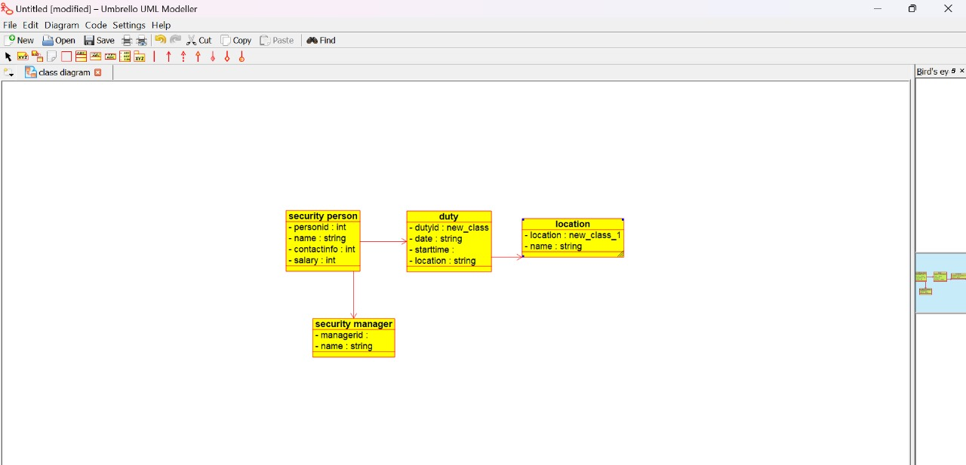
ACTIVITY DIAGRAM:
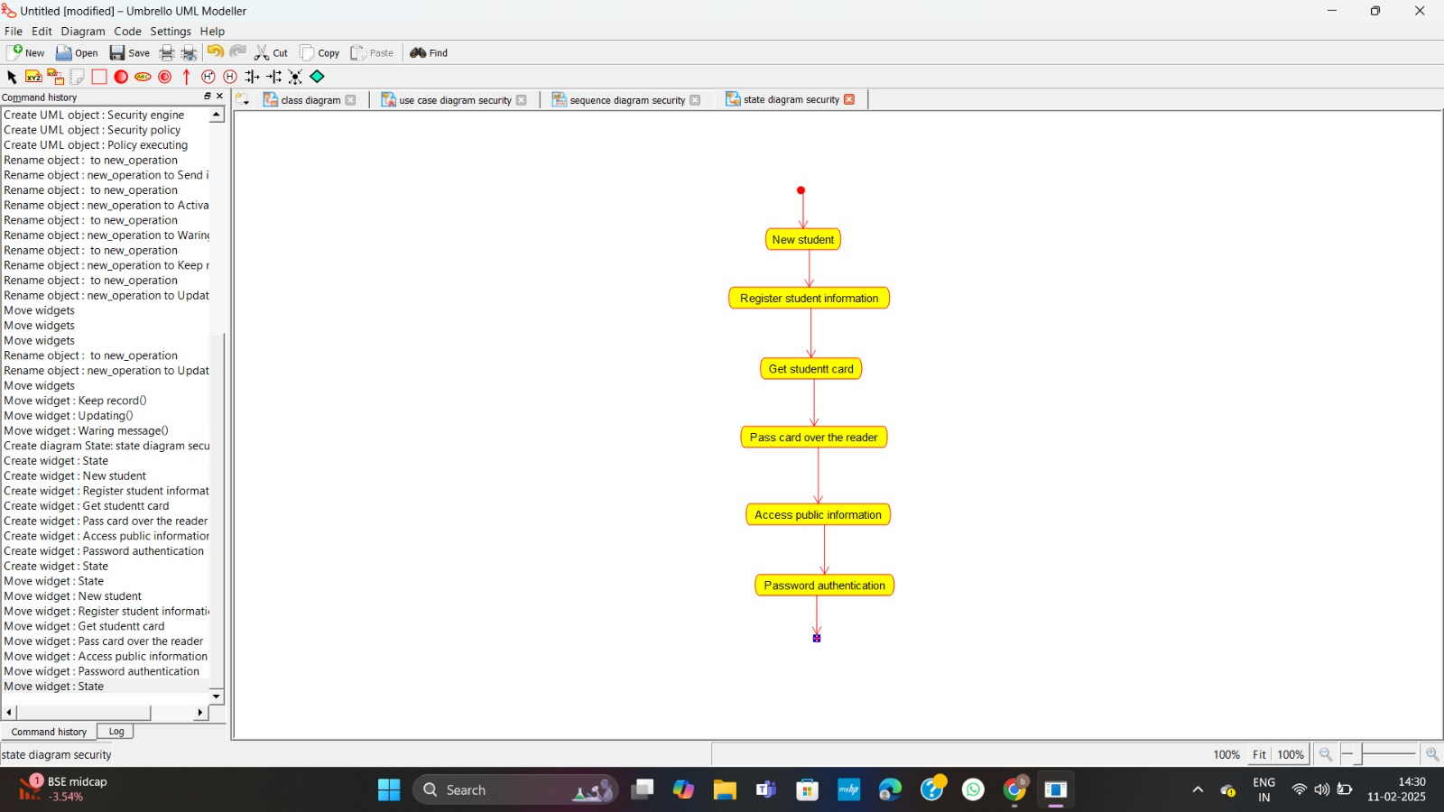

STATE DIAGRAM:
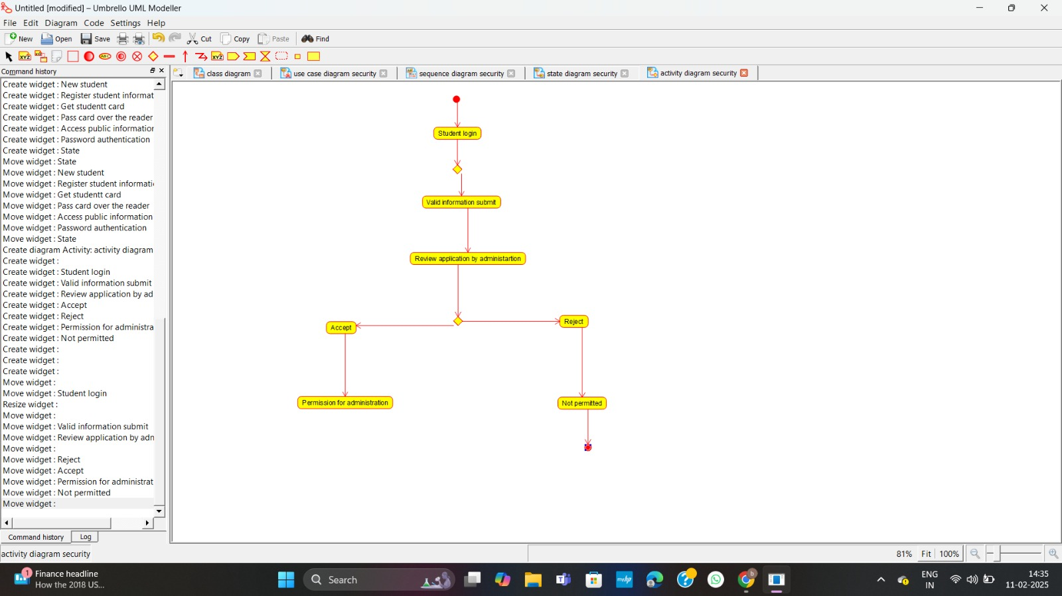

SEQUENCE DIAGRAM:
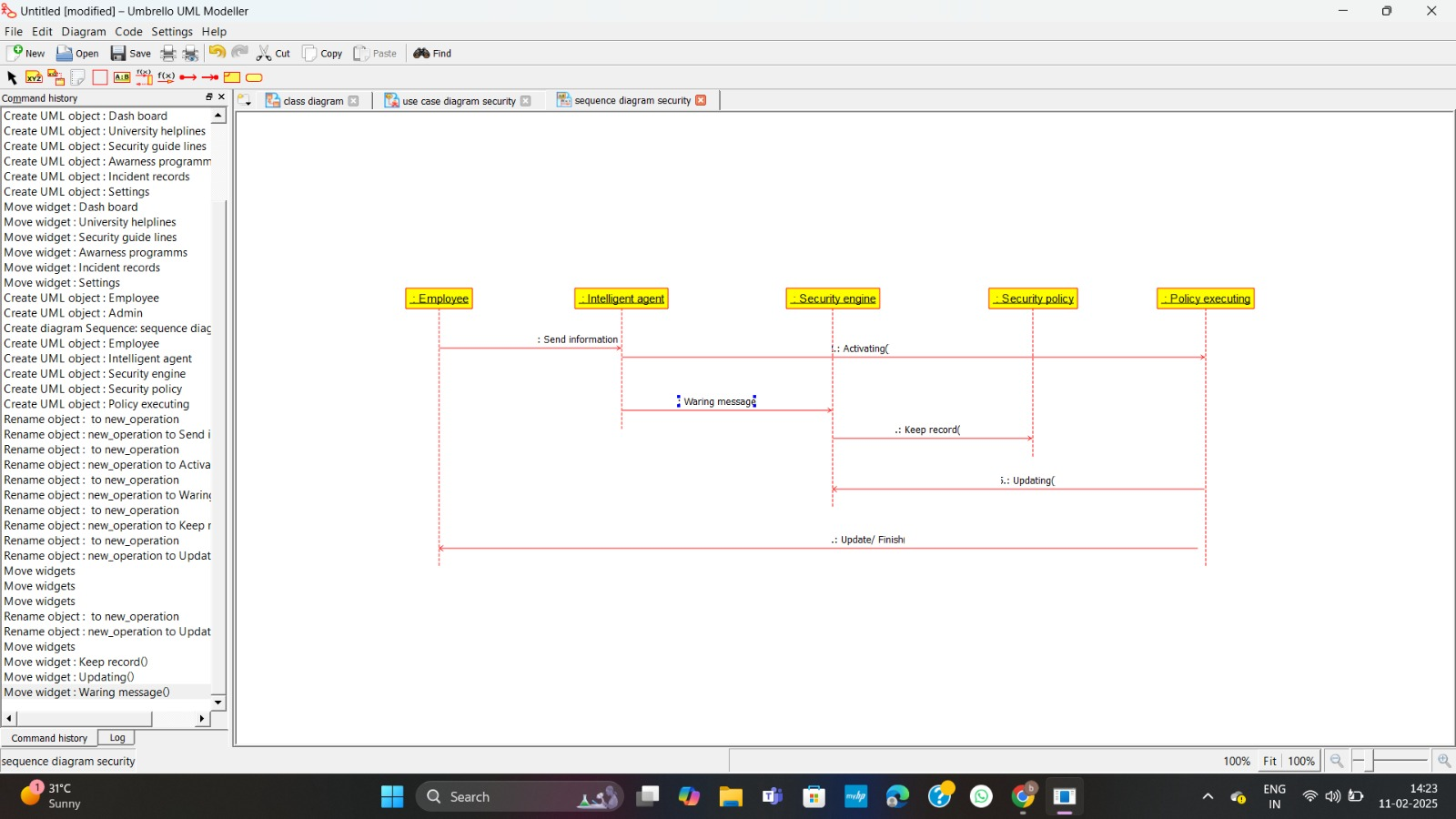

COMPONENT DIAGRAM:
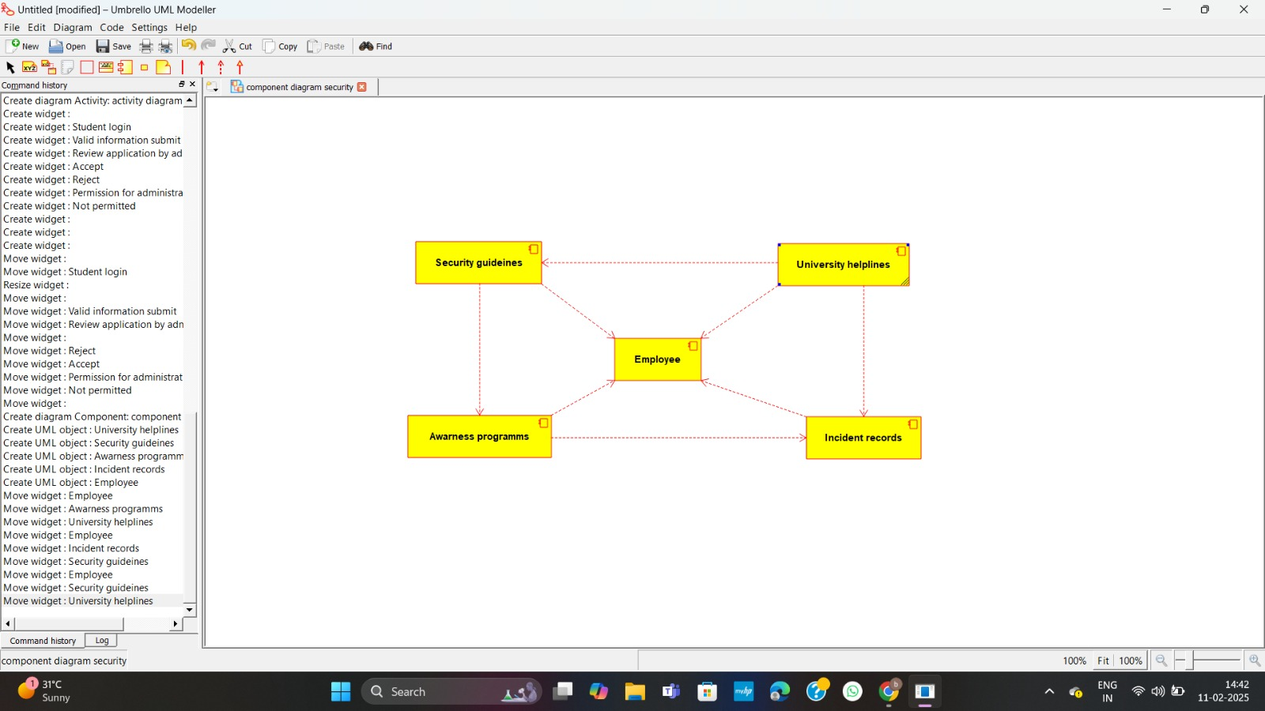

DEPLOYMENT DIAGRAM:
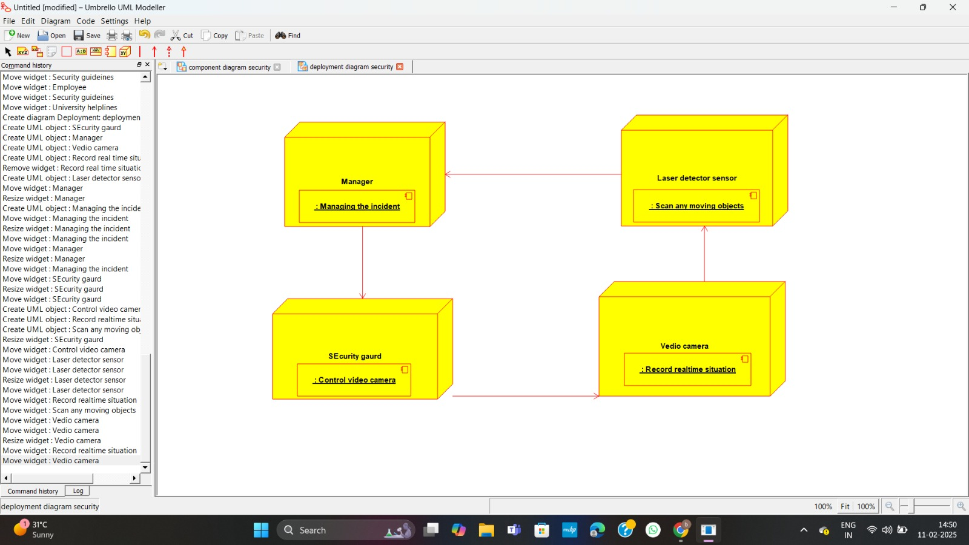

RESULT:

The Online Security Management System class diagram has been successfully created, illustrating the structure and interactions of classes, facilitating efficient management of security personnel, duty schedules, leave management, and payment calculation.

